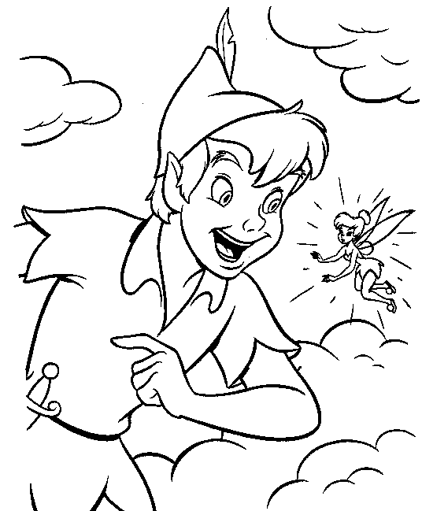
______________________________________________
naslov knjige
Pisac: ____________________________________________________________________________________________
Izdvoji nekoliko zanimljivosti iz piščeva života!
______________________________________________
______________________________________________________________________________________________________________________________________________________________________________________________________________________________________________________________________________________________________________________________________________________________________________________________________________________________________________________________________________________________________________________________________________________________________________________________________________________________________________________________________________________________________________________________
Uz pomoć slika napiši imena likova, te ih oboji !
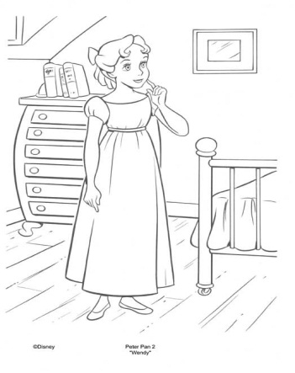 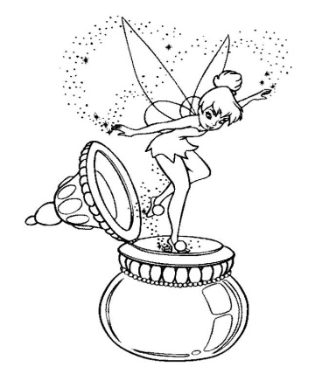 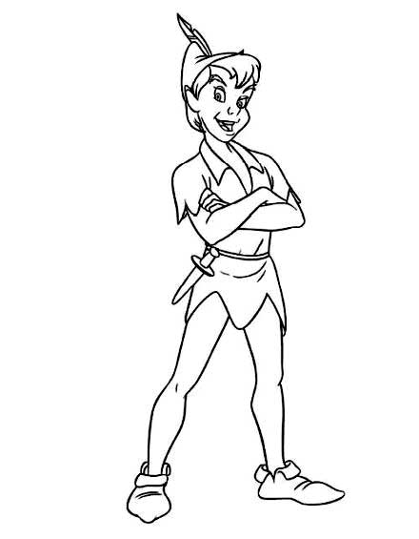
_____________________ _________________________ ________________________
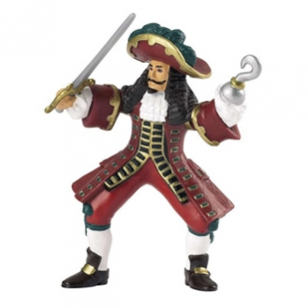
Kako se zove najveći neprijatelj Petra Pana? ___________________________
Napiši njegove osobine !!!
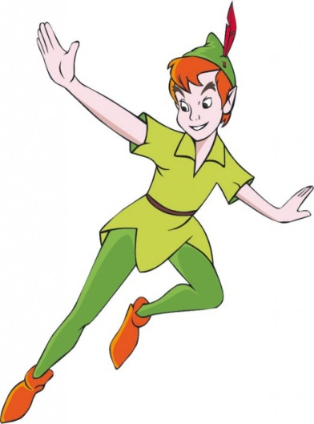
_________________________________________________________________________________________________________________________________________________________________________________________________________________________________________________________________________________________________________________________________________________________________________________________________________________________________________________________Ukratko opiši vanjski izgled Petra Pana !
_________________________________________________________________
_________________________________________________________________
_________________________________________________________________
_________________________________________________________________
_________________________________________________________________
_________________________________________________________________
_________________________________________________________________
_________________________________________________________________
_________________________________________________________________
Kako se nazivaju dječaci s kojima živi Petar Pan i gdje oni žive?
______________________________________________________________________________________________________________________________________________________________________________________________________________________________________________________
Zašto se dječaci nazivaju izgubljenim dječacima? Što misliš, jesu li oni bili sretni bez svojih majki ?!
________________________________________________________________________________________________________________________________________________________________________________________________________________________________________________________________________________________________________________________________________________________________________________________________
Ukratko napiši kako je završila priča o Petru Panu, izgubljenim dječacima i kapetanu Kuki!!
____________________________________________________________________________________________________________________________________________________________________________________________________________________________________________________________________________________________________________________________________________________________________________________________________________________________________________________________________________________________________________________________________________________________________________________________________________________________________________________________________________________________________________________________________________________________________________________________________________________________________________________________________________________________________________________________________________________________________________________________________________________________________________________________________________________________________________________________________________________________________________________________

Napiši svoje mišljenje o pročitanoj knjizi! Što ti se najviše svidjelo, a što nije kada si čitao/čitala knjigu?
__________________________________________________________________________________________________________________________________________________________________________________________________________________________________________________________________________________________________________________________________________________________________________________________________________________________________________________________________________________________________________________________________________________________________________________________________________________________________________________________________________________________________________________________________________________________________________________________________________________________________________________________________________________________________________________________________________________________________________________________________________________________________________________________________________________________________________________________________________________________________________________________________________________________________________________________________________________________________________________________________________________________________________________________________________________________________________________
Ilustriraj najljepši događaj !!!

IME I PREZIME UČENIKA: ________________________________________________________

