r _ s s _ t s _ k č_ j



k _ p j _ ž b _ k d _ m

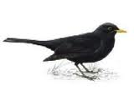

k _ s k _ š k _ p g _ l

ć _ p l _ v c _ r d _ r

p _ ć m _ č m _ d n _ j
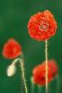


l _ k p _ s m _ k o _ o

r _ t r_ k n _ ž r _ ž

p _ ž p _ t p _t m _ š



s _ m s _ l š _ l s _ r

v _ l v _ k z _ c u _ o

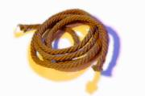
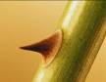


z _ d u _ e t _ n v _ r

z _ b ž _ r dž _ m p _ nj

